The script file final_project_database_cis467.sql creates a database which contains the 11 tables (the database schema is below), with transactional data related to some company operations.

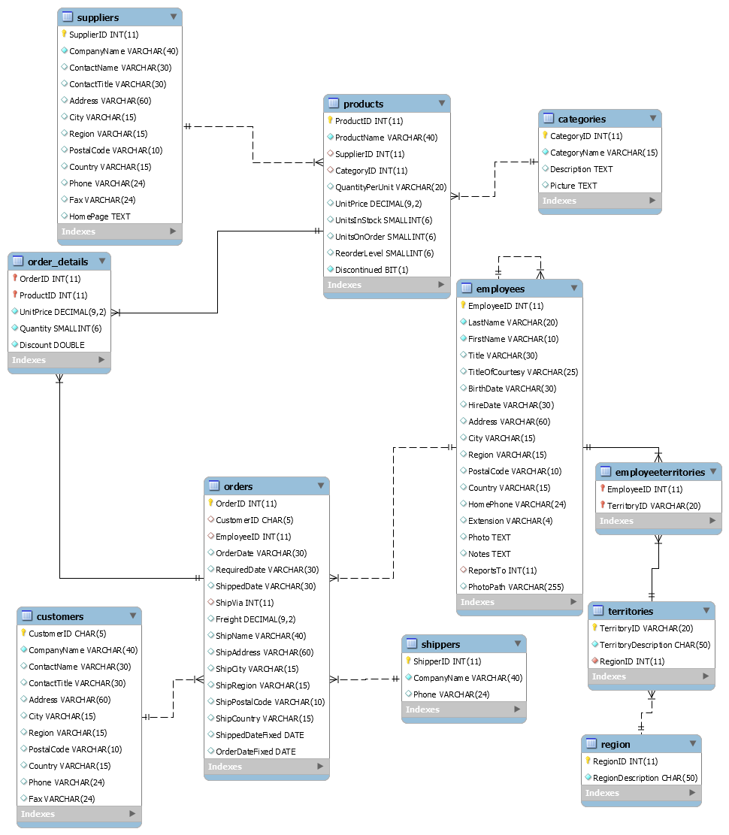

Please put all of your work into **this** **single Word doc and also submit a Tableau Workbook file .twb and the Excel file of your Data Warehouse that you used for Tableau visualizations**. Please see instructions for Tableau below in the question 3.

1. **(121 points)** Design and create a data warehouse for the provided database. The decisions about which fields to include and how to aggregate the data are left to you. You do not need to include every single data point from the 11 tables given. Use your judgement as to what will be interesting/useful for the organization. But please make sure that you pull (combine) data from **at least six tables** and compute relevant aggregate statistics. Please compute relevant aggregate statistics for each table that you join. In your queries later in part 2, you may join your Data Warehouse with other tables to answer useful questions. Please see many examples from class lectures and you may adapt those codes for your purpose (for this dataset).

**Submit a screenshot of the first 25 rows of your data warehouse (paste into this Word document) and the SQL code that you used to create it. Please copy and paste your SQL code into this Word document. If your PC does not show 25 rows of data, please submit what you have (i.e., rows you can see on a screenshot) with a comment that you cannot show 25 rows of data. Please add a description of what your Data Warehouse will be tracking for a company.**

**Code：**

USE cis467_final_project;

-- Part 1

-- create a consumer data warehouse which contains seven tables: Customers, Orders, Order_details, Products, Shippers, Employees and Categories.

SET sql_mode = (SELECT REPLACE(@@SQL_MODE, "ONLY_FULL_GROUP_BY", ""));

CREATE OR REPLACE VIEW customersDW AS

SELECT Orders.CustomerID, Customers.CompanyName AS CustomerName, Customers.City, Customers.Country,Customers.Region,

Order_Details.ProductID, Products.ProductName, Products.CategoryID, Categories.CategoryName,

Products.UnitPrice as Product_unitprice, Products.UnitsInStock,

(Products.UnitPrice*UnitsInStock) as TotalPrice,

Order_Details.Quantity, Order_Details.Discount,

ROUND((Order_Details.UnitPrice*Quantity*(1-Discount)/100)*100,2) AS ExtendedPrice,

CustomerOrderCounts.OrderCount,

NTILE(4) OVER (ORDER BY CustomerOrderCounts.OrderCount) AS CustomerGroup,

Orders.OrderID, Orders.OrderDate, Orders.RequiredDate, Orders.ShippedDate,

DATEDIFF(STR_TO_DATE(Orders.RequiredDate,"%m/%d/%Y"),STR_TO_DATE(Orders.OrderDate,"%m/%d/%Y")) as delivery_days,

Orders.Freight, Orders.ShipName, Orders.ShipCity, Orders.ShipRegion, Orders.ShipCountry,

Shippers.CompanyName As ShipperName,

CONCAT(FirstName, ' ', LastName) AS Salesperson

FROM Shippers JOIN

(Categories JOIN

(Products JOIN

(

(Employees JOIN

(Customers JOIN Orders ON Customers.CustomerID = Orders.CustomerID)

ON Employees.EmployeeID = Orders.EmployeeID)

JOIN Order_Details ON Orders.OrderID = Order_Details.OrderID)

ON Products.ProductID = Order_Details.ProductID)

ON Products.CategoryID = Categories.CategoryID)

ON Shippers.ShipperID = Orders.ShipVia

LEFT JOIN (

SELECT Customers.CustomerID, COUNT(Orders.OrderID) AS OrderCount

FROM Customers

LEFT JOIN Orders ON Customers.CustomerID = Orders.CustomerID

GROUP BY Customers.CustomerID

) AS CustomerOrderCounts ON Customers.CustomerID = CustomerOrderCounts.CustomerID;

**Outputs：**We divided this data warehouse into several sections for screenshot because it is quite wide.

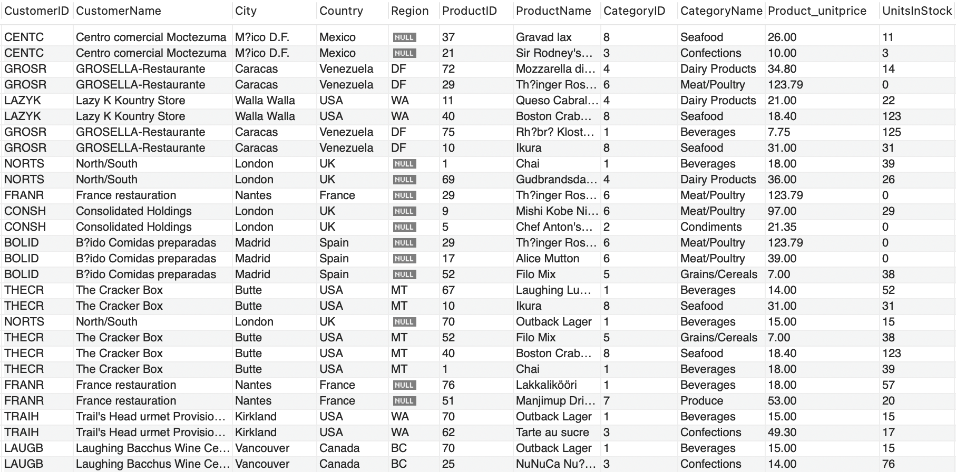

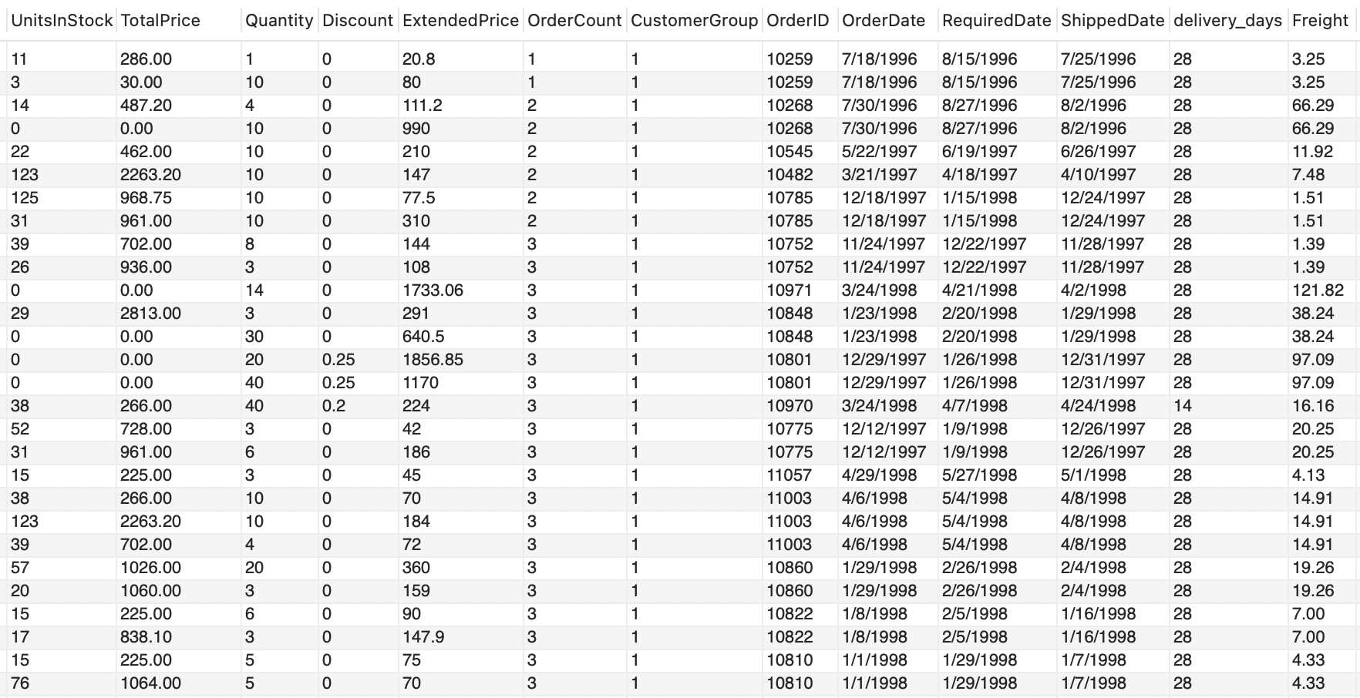

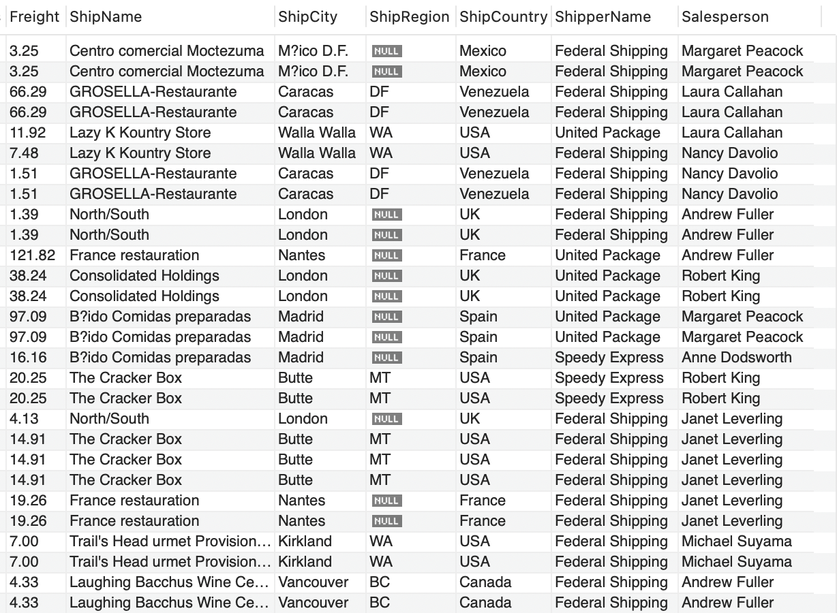

We create a consumer data warehouse which contains seven tables: Customers, Orders, Order_details, Products, Shippers, Employees and Categories.

This data warehouse also includes:

1. Create a CustomerGroup column in customersDW view, which shows the grouping of customers based on the number of orders they have placed.

2. Compute the days between Order Date and Required Date to show the delivery efficiency.

3. Compute extended price for customers.

4. Compute total price for each product.

2. **(104 points)** Create **eight** SQL queries **on your data warehouse** (not on the original dataset) that answer interesting questions. At least **6** queries should be more complex queries. For example, more complex queries could include Joins, a Group By, UNION elements or a subquery or use some aggregate functions and summary calculations (see examples in the class lectures’ slides).

**Submit a copy of each query SQL code (paste into this Word document), and the screenshot of each query results (or the first 25 rows if it is longer or how many rows you can get on your PC) and full description of the question your SQL code was addressing and what you found in the results. The question that each query answers should be useful for a company to make decisions and act upon.**

1. Identify price-sensitive customers: customer whose discount orders/total purchase orders>50%.

**Code:**

SELECT CustomerID, CustomerName,

SUM(CASE WHEN Discount > 0 THEN 1 ELSE 0 END) AS DiscountedOrders,

COUNT(*) AS TotalOrders,

round(CAST(SUM(CASE WHEN Discount > 0 THEN 1 ELSE 0 END) AS FLOAT) / COUNT(*),2) AS DiscountRatio

FROM customersDW

GROUP BY CustomerID

having DiscountRatio >= 0.50

ORDER BY DiscountRatio DESC;

**Outputs:**

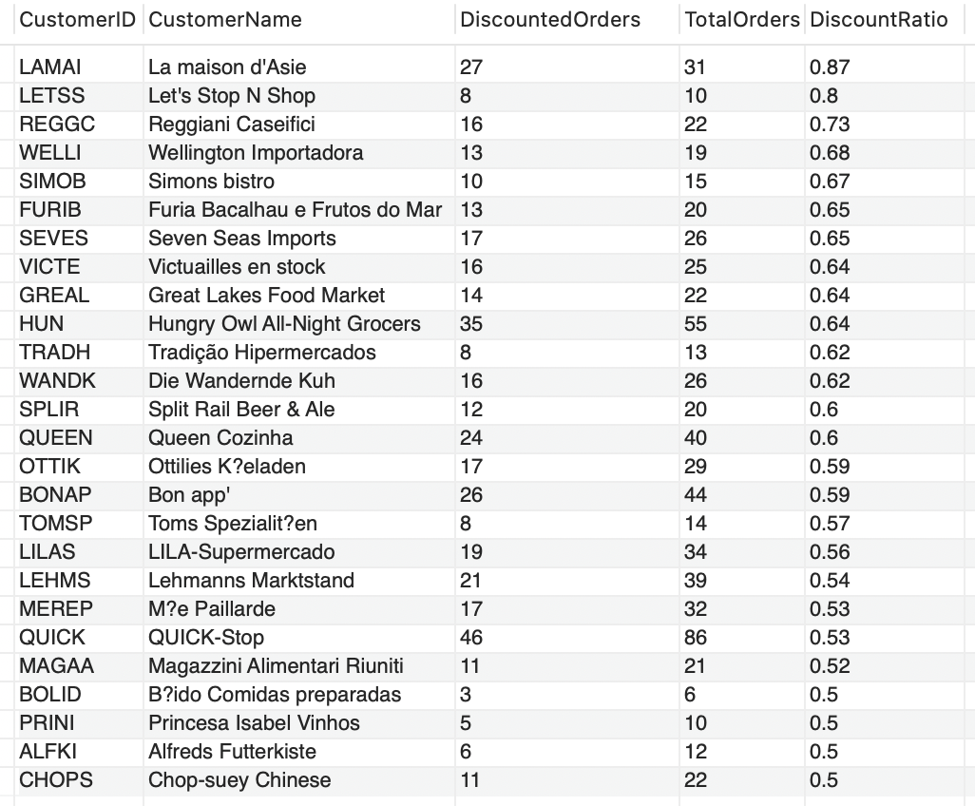

By calculating the customer group with more than 50% of their orders being discounted, we can identify the price-sensitive customer segment. We can then focus on sending promotional messages to this group to encourage them to place orders. This approach can help boost sales order volume.

2. Find customers in each country whose purchasing power exceeds the average.

**Code：**

SELECT c.CustomerID, c.CustomerName, c.Country, c.TotalSpending

FROM (

SELECT CustomerID, CustomerName, Country,

round(SUM(extendedprice),2) AS TotalSpending

FROM customersDW

GROUP BY CustomerID, CustomerName, Country

) AS c

JOIN (

SELECT Country, AVG(TotalSpending) AS AvgCountrySpending

FROM (

SELECT CustomerID, CustomerName, Country,

round(SUM(extendedprice),2) AS TotalSpending

FROM customersDW

GROUP BY CustomerID, CustomerName, Country

) AS subquery

GROUP BY Country

) AS avg_c ON c.Country = avg_c.Country

WHERE c.TotalSpending > avg_c.AvgCountrySpending

ORDER BY c.Country, c.TotalSpending DESC;

**Outputs：**

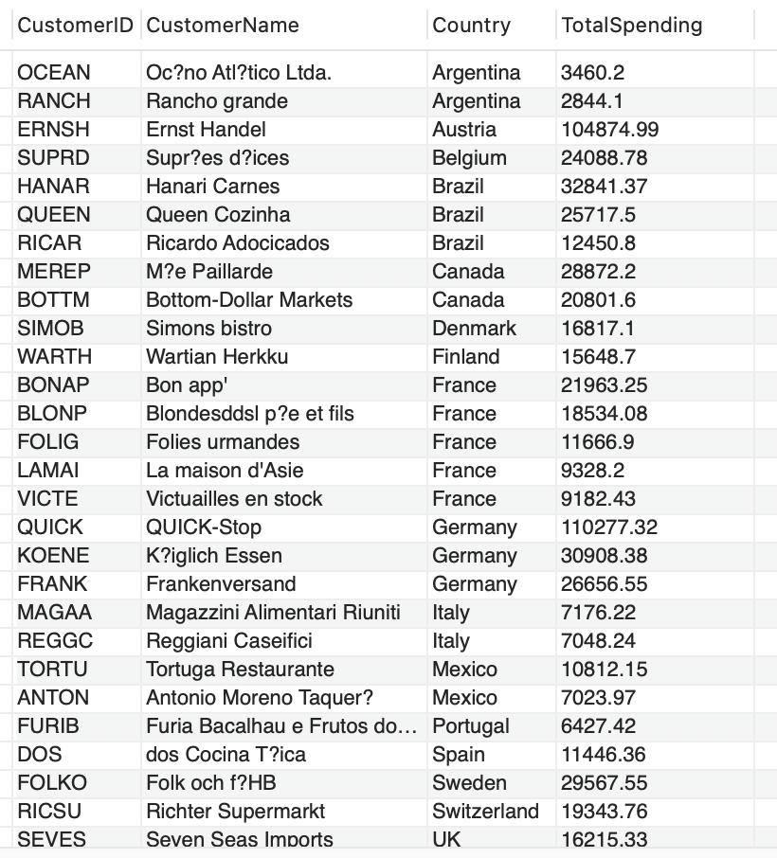

This approach allows us to identify high net-worth customer segments in each country. It's essential to pay particular attention to the retention rates of these customers to ensure the company's revenue. We can provide targeted VIP services to these customers to enhance their retention rates.

3.Sort by country to determine which country has the highest purchasing power (in terms of monetary value).

**Code：**

SELECT cs.Country, cs.CategoryName, cs.TotalSpending

FROM (

SELECT Country, CategoryName, round(SUM(extendedprice),2) AS TotalSpending

FROM customersDW

GROUP BY Country, CategoryName

) AS cs

JOIN (

SELECT Country, MAX(TotalSpending) AS MaxSpending

FROM (

SELECT Country, CategoryName,

round(SUM(extendedprice),2) AS TotalSpending

FROM customersDW

GROUP BY Country, CategoryName

) AS subquery

GROUP BY Country

) AS max_cs ON cs.Country = max_cs.Country AND cs.TotalSpending = max_cs.MaxSpending

ORDER BY cs.Country, cs.TotalSpending DESC;

**Outputs：**

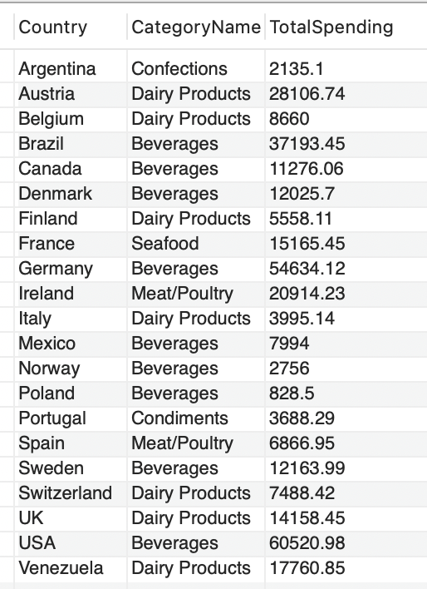

Identifying countries with stronger purchasing power enables us to focus on understanding the needs of customers in these countries and strive to provide the products they require. This approach can help increase the company's revenue and profit by catering to the demands of customers in these affluent nations.

4. Calculate the product preferences of customers in each country.

**Code：**

SELECT Country, round(SUM(extendedprice),2) AS TotalSpending

FROM customersDW

GROUP BY Country

ORDER BY TotalSpending DESC;

**Outputs：**

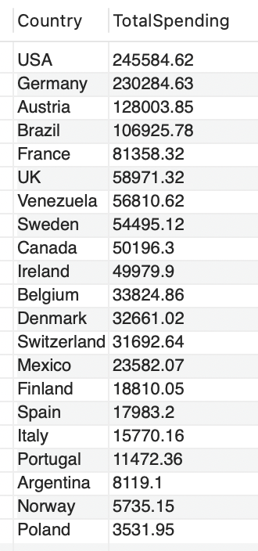

Identifying the preferred products of customers in each country allows us to offer different products more targeted to each nation, thereby increasing product sales efficiency. This approach reduces product storage time in warehouses, ultimately lowering company costs.

5.Find the top two cities in terms of total sales for each country.

**Code：**

WITH RankedCities AS (

SELECT Country, City,

ROUND(SUM(ExtendedPrice),2) AS TotalSales,

ROW_NUMBER() OVER (PARTITION BY Country ORDER BY SUM(ExtendedPrice) DESC) AS CityRank

FROM customersDW

GROUP BY Country, City

)

SELECT Country, City, TotalSales

FROM RankedCities

WHERE CityRank <= 2

ORDER BY Country, CityRank;

**Outputs：**

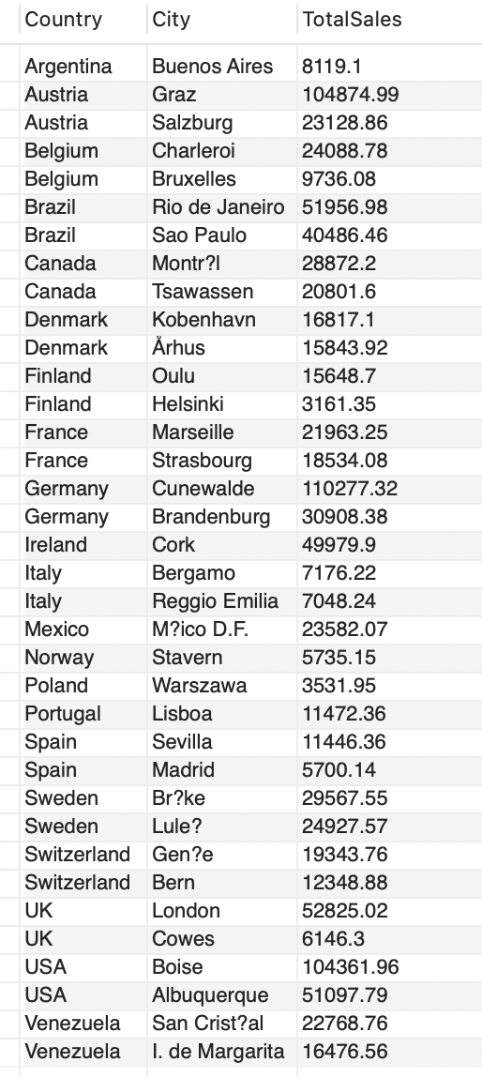

It's useful to know which cities in each country serve as the primary sales markets. This enables businesses to concentrate their assets and efforts. A business may consider expanding its workforce, bringing on more inventory, or committing additional resources to meet demand in cities that perform better than others in a certain country. Such a query provides invaluable market intelligence, helping businesses make better decisions and allocate their resources more effectively.

6. Identify the most loyal customers: Calculate the average order amount for each customer and find customers whose total purchase amount is higher than the average to determine the most loyal customers.

**Code:**

SELECT CustomerID, CustomerName, AvgOrderAmount

FROM (

SELECT CustomerID, CustomerName, round(AVG(extendedprice),2) AS AvgOrderAmount

FROM customersDW

GROUP BY CustomerID

) AS CustomerSpending

WHERE AvgOrderAmount > (SELECT AVG(AvgOrderAmount)

FROM (

SELECT round(AVG(extendedprice),2) AS AvgOrderAmount

FROM customersDW

GROUP BY CustomerID

) AS OverallAvgOrderAmount

)

ORDER BY AvgOrderAmount DESC;

**Outputs:**

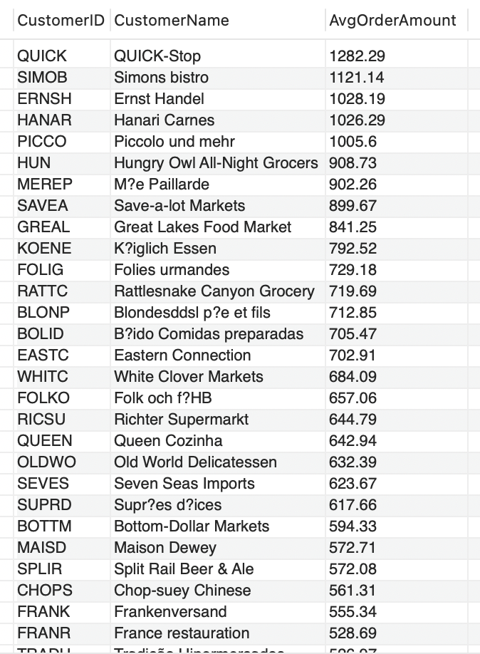

Businesses can identify clients who contribute more to their revenue by identifying individuals whose purchase quantities are higher than the other. These clients are frequently valued higher in the market. Identifying loyal customers helps businesses to focus on those who bring the most value, ensuring that they remain engaged and satisfied, leading to sustainable revenue and growth.

7. Analyze customer purchasing behavior: Determine the product category most frequently purchased by each customer in their purchase history to understand their purchasing preferences.

**Code:**

SELECT c.CustomerID, c.CustomerName, c.CategoryName, p.CategoryID, SUM(c.Quantity) AS TotalQuantity

FROM customersDW c

JOIN products p

ON c.ProductID = p.ProductID

GROUP BY c.CustomerID, c.CustomerName, p.CategoryID

HAVING SUM(c.Quantity) >= ALL (SELECT SUM(c2.Quantity)

FROM customersDW c2

JOIN products p2 ON c2.ProductID = p2.ProductID

WHERE c2.CustomerID = c.CustomerID AND p2.CategoryID != p.CategoryID

GROUP BY p2.CategoryID

)

ORDER BY c.CustomerID;

**Outputs:**

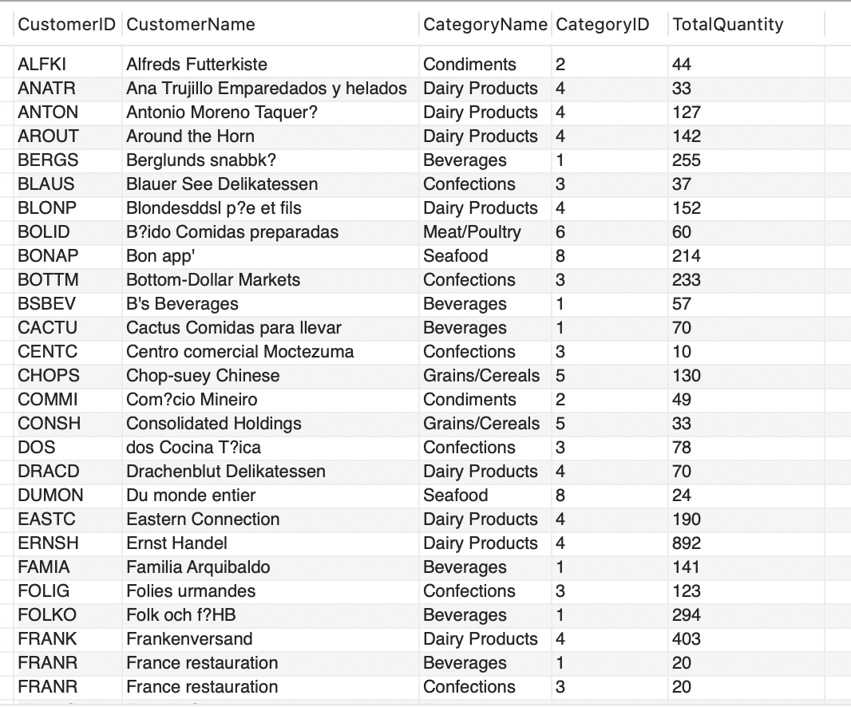

Analyzing the customer's purchase history can help businesses segment customers, identify the most valuable customer groups, and develop more targeted marketing strategies, such as creating customized promotional activities or advertisements for specific customer segments and providing them with a higher level of service and attention, thus improving the conversion rate and customer satisfaction.

8. Understanding Customer Purchase Time Trends

**Code：**

SELECT CustomerID, CustomerName,

YEAR(STR_TO_DATE(OrderDate,"%m/%d/%Y")) AS OrderYear,

QUARTER(STR_TO_DATE(OrderDate,"%m/%d/%Y")) AS OrderQuarter,

MONTH(STR_TO_DATE(OrderDate,"%m/%d/%Y")) AS OrderMonth,

COUNT(OrderID) AS OrderCount

FROM customersDW

GROUP BY CustomerID, CustomerName,

OrderYear, OrderQuarter, OrderMonth

ORDER BY CustomerID, OrderYear, OrderQuarter, OrderMonth;

**Outputs：**

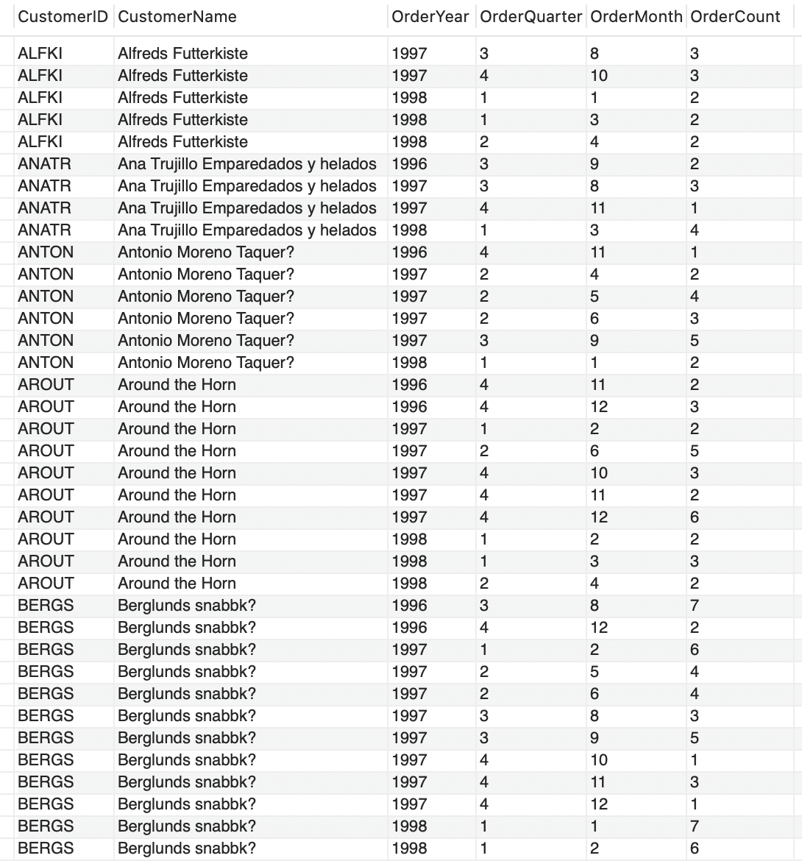

Analyze the order dates in the customer's purchase history to identify trends in their purchasing behavior across different seasons, months, or years. This will help you understand when customers are most active in making purchases. Then, we can run promotional campaigns during the less active purchasing months for each customer, aiming to stimulate orders. During the active purchasing months, we can ensure efficient shipping and provide excellent post-sale services to enhance the customer's perception of the company, thereby maintaining a positive company reputation.

3. (**75 points**) Create **five** Tableau individual visualizations (graphs) **on your data warehouse** with valuable information to present findings to senior management of the company. Save each visualization as a png file (as we will practice in the lab 5) and paste each individual visualization png file **into this Word** document with the full explanation of what the visualizations show, how they are useful to a company and how company management could make decisions based on what you show. Finally, combine those **five** visualizations into one **Dashboard** (as we will practice in the lab 5), and save this Dashboard as a png file and **paste the Dashboard into this Word** document.



**The geographic visualization map showing customer sales by country**

It shows the total sales generated from customers in each country. The darker shade represents higher sales. It allows the management to quickly see which countries bring in the most revenue. They can use this to guide decisions around marketing budget allocation, localization efforts, and expansion plans.This is useful because it allows management to see which countries represent the largest markets and revenue sources. The CEO could decide to increase marketing spend in the USA to further grow sales there. The CMO may launch localization and translation efforts in the top countries to improve engagement. The COO could set up new offices or warehouses in countries like the UK, Germany, and France to improve operations and logistics for those sizable markets.



This visualization shows total sales contributed by each product category. The management can use this to make decisions around product portfolio and inventory planning. More resources can be allocated to the top selling categories. The COO can allocate more warehouse space for Beverages since it is the top seller. The Marketing head can run promotions and offers on Condiments to boost sales for this weak category. The CFO can optimize procurement budget across categories based on their revenue contribution.



This graph helps us understand which product is famous in which country as the points higher up represents the most sales of particular product. This visualization enables management to analyze which products sell well in different countries. This visualization provides product-country sales insights to aid localized marketing, inventory planning, logistics optimization and sales growth strategies.

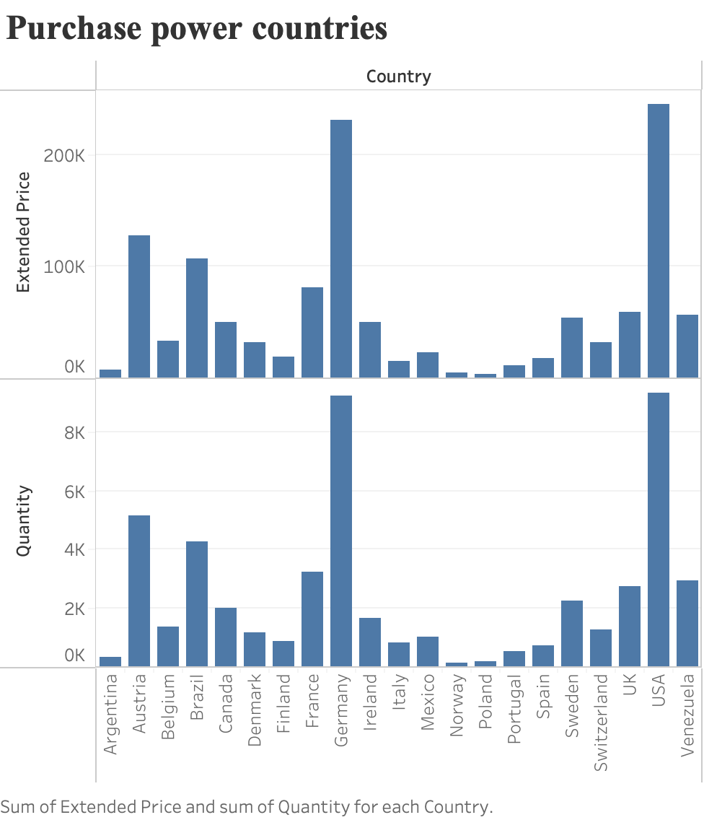

This bar graph provides purchasing power by country. It provides an accurate revenue-based view of the importance and performance of each country that accounts for pricing, product mix and order value differences. This enables better financial analysis, forecasting, targeting, and decision making driven by revenue rather than unit quantities.

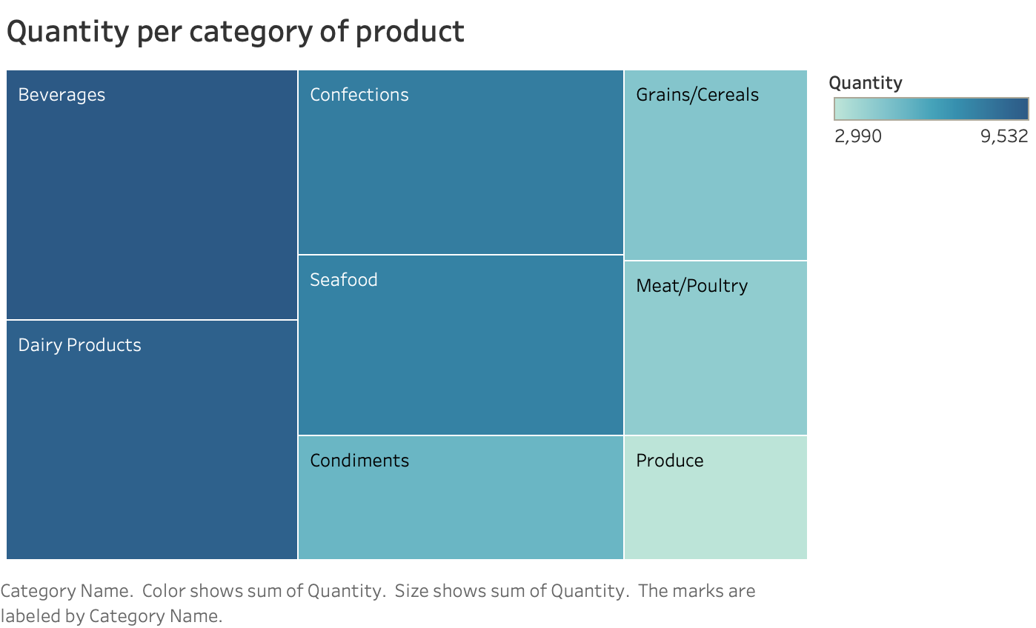

This graph represents the quantity per category of product. Comparing category and quantity sales can help businesses identify trends, make data-driven decisions, and allocate resources efficiently. By understanding which categories and units are driving sales growth, businesses can allocate resources towards high-growth areas, leading to potential increases in overall revenue.